LUCIA MANJENGWA
versus
THE MINISTER OF DEFENCE AND WAR VETERANS AFFAIRS

and
AIR MARSHALL AIR FORCE OF ZIMBABWE
and
MATTHEW MUSHINGA

HIGH COURT OF ZIMBABWE

KATIYO J
HARARE 18 June 2025 &11 February 2026

Civil Trial

SV Chava, for the plaintiff
P Chibanda, for the first and second defendants No appearance for the third defendant

KATIYO J

INTRODUCTION

This is a claim for damages for loss of support arising from the death of the plaintiff’s husband, Mudavanhu Manjengwa, who succumbed to injuries sustained in a motor vehicle accident on 21 December 2019. The accident was caused by the negligent driving of the 3rd defendant, an employee of the 1st and 2nd defendants, who was driving a motor vehicle owned by the Air Force of Zimbabwe.
The issues for determination are:

- Whether the 1st and 2nd defendants are vicariously liable for the delict of the 3rd defendant and, if so, the degree of such liability;
- The quantum of damages to be awarded to the plaintiff in the interests of justice.

WHETHER THE 1ST AND 2ND DEFENDANTS ARE VICARIOUSLY LIABLE AND THE DEGREE OF LIABILITY
It is common cause that the 3rd defendant was at all material times an employee of the 1st and 2nd defendants and that he was driving a motor vehicle owned by the Air Force of Zimbabwe when the accident occurred. The central dispute is whether he was acting within the course and scope of his employment, or whether he was on a “frolic of his own”.

The classic test for vicarious liability is settled. In Biti v Minister of State Security 1999
(1) ZLR 165 (SC), the Supreme Court reaffirmed that the enquiry is whether the wrongdoer was engaged in the affairs or business of the employer at the time the delict was committed. In Feldman (Pty) Ltd v Mall 1945 AD 733, WATERMEYER CJ articulated the creation of risk doctrine, holding that where an employer creates a risk by entrusting work, equipment or authority to an employee, liability may attach if the harm falls within that risk. This approach has been consistently applied in Zimbabwe, including in Munengani v Minister of Defence HH 45/06.
The defendants argued that the 3rd defendant acted without authority, outside working hours, and without a valid military driving licence. However, the evidence reveals that the 3rd defendant was entrusted with control of a fleet of vehicles, despite being unlicensed, and that the 1st and 2nd defendants failed to put in place effective control mechanisms to prevent him from driving. No logbooks, authorisation forms, or reports of vehicle theft were produced.
This court aligns itself with the reasoning in Minister of Police v Rabie 1986 (1) SA 117 (A), which established that even where an employee acts partly for personal purposes, the employer may still be liable if there is a sufficiently close link between the wrongful conduct and the risk created by the employment.
The 1st and 2nd defendants, by issuing a service vehicle and placing it under the control of an unlicensed officer, created a foreseeable risk to the public. The accident that occurred was not too remote from that risk. Their omission to supervise, restrict or prevent the 3rd defendant from driving constitutes negligence independent of vicarious liability.
Accordingly, I find that:

- The 3rd defendant was negligent and is the primary wrongdoer;

- The 1st and 2nd defendants are vicariously liable, alternatively jointly liable on the basis of creation of risk.
On the degree of liability, fairness and justice require an apportionment. While the 3rd defendant’s conduct was the immediate cause of the accident, the negligence of the 1st and 2nd defendants was substantial. I accordingly apportion liability as follows:
- 1st and 2nd defendants: 95%

- 3rd defendant: 5%

THE QUANTUM OF DAMAGES FOR LOSS OF SUPPORT

The right of a widow and children to claim loss of support is well established in Zimbabwean law. In Mutandiro v Mudzimu 1998 (1) ZLR 56 (SC) and Mashavira v Nyaradzo Funeral Services (Pvt) Ltd 2000 (1) ZLR 156 (H), the courts confirmed that the wrongful death of a breadwinner gives rise to a compensable delict.
The guiding principles on assessment were set out in Jameson’s Minors v Central South African Railways 1908 TS 575, where Innes CJ emphasised that the court must exercise a broad equitable discretion, considering the maintenance the deceased would probably have provided. This approach was reaffirmed in Hulley v Cox 1923 AD 234, where the court warned against rigid actuarial precision and endorsed a balanced consideration of the equities of the
case.
In casu, the evidence establishes that:

- The deceased was legally married to the plaintiff and had a duty of support;

- He earned the equivalent of USD 931.20 per month;

- He was 44 years old at the time of death and would likely have worked until retirement at age 55, giving 11 years of remaining earning capacity.
The proposed calculation of USD 122,918.40 for loss of support is reasonable and consistent with awards in comparable cases such as Mabaire v Jailosi HH 228/10 and Kanengoni v Minister of Justice HH 156/18.
Taking into account contingencies and contributory negligence, and applying the 5% deduction attributable to the 3rd defendant, the just award for loss of support is:
USD 116,772.48 or its Zimbabwean dollar equivalent at the prevailing interbank rate.

DISPOSITION

In the result, it is ordered that:

- The 1st and 2nd defendants are jointly and severally liable, the one paying the other to be absolved, for 95% of the plaintiff’s proven damages.
- The plaintiff is awarded USD 116,772.48 or its Zimbabwean dollar equivalent at the prevailing interbank exchange rate, being damages for loss of support.
- Interest shall accrue on the above amount at the prescribed rate from the date of summons to the date of full payment.

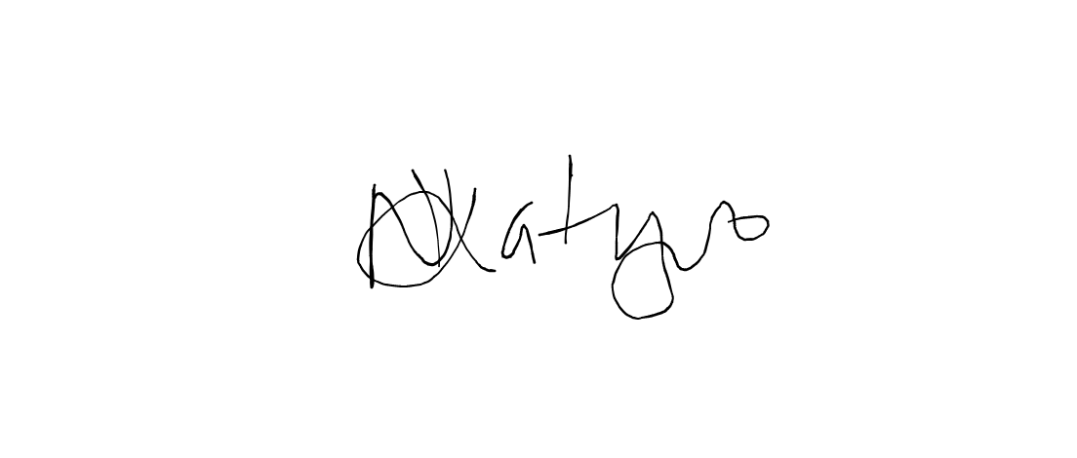
4. The defendants shall pay the costs of suit
KATIYO J………………………………..

Legal Resources Foundation, plaintiff’s legal practitioners
Civil Division of the Attorney General, first and second defendant’s legal practitioners

