
TRANS AFRICAN OIL LIMITED
versus

WILLRED MINERALS AND ENERGY (PRIVATE) LIMITED
and

HALGOR ESTATE (PRIVATE) LIMITED

HIGH COURT OF ZIMBABWE COMMERCIAL DIVISON MANZUNZU J
HARARE;15 July 2024 & 3 June 2025

Civil Trial – Special Plea In Bar

Adv. L Uriri with K Sabao, for the plaintiff
Z J Zvobgo, for the first and second defendants

MANZUNZU J INTRODUCTION
This matter concerns a claim for specific performance arising from a written agreement between the parties. The Plaintiff seeks to compel the Defendants to fulfil their obligations in terms of the agreement. In response, the Defendants have raised a special plea, contending that the agreement is illegal and therefore unenforceable. This judgment is confined to addressing the preliminary point raised in the special plea.

BACKGROUND

- The Plaintiff is Trans Africa Oil Limited, a company duly registered in accordance with the laws of the British Virgin Islands.
- The first Defendant is Willred Minerals and Energy Private Limited and the second Defendant is Halgor Estate Private Limited, both these companies are duly registered in accordance with the laws of the Republic of Zimbabwe.
- On or about 10 November 2021, the Plaintiff and the first Defendant entered into a written agreement, were the Plaintiff agreed to supply the first Defendant with fuel on credit.
- Pursuant to the agreement, the second Defendant bound itself, on behalf of the first Defendant, as guarantor and co-principal debtor for the due payment of the fuel supplied and advanced on

credit by the Plaintiff as security for the due and punctual discharge by the first Defendant of its obligations.
- As security for the fuel supplied on credit, second Defendant caused the registration of Surety Mortgage Bond Number 3414/2022 over a certain piece of land situate in the district of Salisbury called the remainder of Thornicroft Park of Galway Estate measuring 4.1505 hectares, held under Deed of Transfer Number 2193/86.
- The Plaintiff made available fuel to the first Defendant on credit during the period July 2021 to November 2022.
- The Plaintiff supplied fuel worth US$1,471,423.54 (One Million Four Hundred and Seventy- One Thousand Four Hundred and Twenty-Three United States Dollars and Fifty-Four Cents) to the first Defendant. The fuel was duly released by the National Oil Infrastructure Company of Zimbabwe (NOIC) to the first Defendant upon receiving instructions from the Plaintiff.
- In breach of the Fuel Supply Agreement, the first Defendant failed to pay for the fuel supplied and advanced as agreed between the parties.
- As a result, the Plaintiff filed summons with this court seeking payment of the sum of US$1,471,423.54 (One Million Four Hundred and Seventy-One Thousand Four Hundred and Twenty-Three United States Dollars and Fifty-Four Cents), being the value of fuel supplied and advanced on credit to the first Defendant together with interest thereon at the rate of 8% per annum compounded monthly, calculated from the 3first of May 2022 to the date of full and final payment.
- The first and second Defendants in response to the Plaintiff’s claim raise a special plea in bar. The defendants allege the Fuel Supply Agreement, Guarantee and Indemnity Agreement and Surety Mortgage Bond, which the Plaintiff relies upon in pursuit of its claim are void ab initio by reason of illegality; specifically, they contend that the parties entered into the fuel supply agreement and commenced transactions, long before obtaining the Exchange Control Approval as required in terms of s11(1) of the Exchange Control Regulations, 1996 (SI 109/1996).
- The court has to determine if the contract is illegal and thus void ab initio.

ISSUES FOR DETERMINATION

- Whether or not there are material dispute of facts.
- Whether the Fuel Supply Agreement is void ab initio.

THE LAW

WHETHER THERE ARE MATERIAL DISPUTE OF FACTS

- The Plaintiff in response to the special plea in bar argues that the matter cannot be determined solely based on the pleadings and heads of argument, as there is a material dispute of facts that can only be resolved at trial. The Plaintiff asserts that the Special Plea in Bar is ill- advised, requiring substantive evidence and factual analysis, which cannot be adequately addressed at this stage. It was also argued that there is a need for evidence to be led from the Exchange Control Authority to establish the illegality of the agreement as alleged by the Defendants.
- What a dispute of fact entails was explained in Supa Plant Investments (Pvt) Ltd v
Chidavaenzi 2009 (2) ZLR 132 (H) at 136F where the court said:

that:
“A material dispute of fact arises when material facts alleged by the applicant are disputed and traversed by the respondent in such a manner as to leave the court with no ready answer to the dispute between the parties in the absence of further evidence.”
The court in Riozim Private Limited v Falcon Resources Private Limited & Anor SC28-22 held

“……it is evident that a dispute of fact arises where the court is left in a state of reasonable doubt as to which course to take in resolving the matter without further evidence being led.”
Furthermore, the court in Boka Enterprises (Pvt) Ltd v Joowalay & Anor 1988 (1) ZLR 107 (SC) at 114C held that not all disputes of facts necessitate the taking of oral evidence. The court stated that:
“In cases such as this case must be taken not to elevate every alleged dispute of fact into a real issue which necessitates the taking of oral evidence, for to do so might well encourage a lessee against whom ejectment is sought to raise fictitious issues of fact thereby delaying the resolution of the matter to the detriment of the lessor.”
The court in Cobat Trade and Finance v Movement for Democratic Change SC50-2012 held that:

“Consequently, the submission by the plaintiffs that illegality should not have been raised as a special plea and can only be raised on the merits is clearly untenable”.
- The alleged dispute of fact by the Plaintiff does not necessitate the leading of oral evidence. The above cited authorities affirm my position. The defendants rightly brought the special plea before the commencement of the trial, and it is unjustifiable for the Plaintiff to argue that there are material disputes that can only be resolved at trial.
- If anything, the parties are in agreement that when they entered into an agreement and performed part of the agreement, the exchange control authority had not been obtained. The

issue remains on the interpretation of the legislative provisions to ascertain the legality or otherwise of the agreement. This is the duty of the court and not the Exchange Control Office.
- The preliminary point raised by the plaintiff must fail.

WHETHER OR NOT THE FUEL SUPPLY AGREEMENT IS VOID AB INITIO

Clause 3 of the agreement stipulated the conditions precedent. Clause 3 of the agreement reads:

“This agreement in entirety is subject to and condition upon:
3.1.1 This agreement and the guarantee being registered with the Zimbabwe Exchange Control Authorities to enable the Customer and the Guarantor to externalise the payments due to the supplier in terms of this Agreement from time to time and authorising the registration of the Security”
Section 11 of the Exchange Control Regulations 1996 (SI 109/1996) states that;

“11. (1) Subject to subsection (2), unless otherwise authorised by an exchange control authority, no Zimbabwean resident shall—
- make any payment outside Zimbabwe; or
- incur any obligation to make a payment outside Zimbabwe.”
In terms of s 11 of the Exchange Control Regulations, 1996 an exchange control authority is needed prior to one making payment outside Zimbabwe or incurring any obligation to make payment outside Zimbabwe. The Defendant was supposed to obtain such authority in terms of s11 Of the Exchange Control Regulations, 1996. The court in Delta Beverages (Pvt) Ltd v Blakey Investments (Pvt) Ltd SC 59-22, held that:
……. “it is trite that the obligation was on the appellant as the importer to obtain the permit. The appellant did not state that it in fact received the goods and consumed them without having first obtained the requisite import permit. Such a permit would have been one of the licences or authority appellant warranted to have complied with in terms of the clause on warrants, representations, and undertaking. The court a quo cannot be faulted for not finding for the appellant on this aspect as well.”
The general rule is that courts cannot enforce an agreement that violates the law, in Dube v Khumalo 1986(2) ZLR 103 (SC) at p 109 the court said:
“There are two rules which are of general application: The first is that an illegal agreement which has not yet been performed, either in whole or in part, will never be enforced. This rule is absolute and admits no exception.”
The court in Chioza v Siziba SC16-2011 also affirms the above position when the court noted that the general principle is that courts will not enforce an agreement prohibited by the law.

Courts cannot enforce an agreement that is prohibited by the law. As cited by the above authorities an illegal agreement cannot be enforced. Therefore, the fuel supply agreement entered by the Plaintiff and Defendants is void ab initio. It is illegal and thus unenforceable.
In conclusion, the fuel supply agreement is void ab initio an illegal document is unenforceable. The special plea in bar raised by the defendant has merit. The agreement is illegal and cannot be enforced by any court of law.

DISPOSITION

- The preliminary point raised by the plaintiff alleging presence of material dispute of facts is hereby dismissed.
- The special plea raised by the defendants be and is hereby upheld with costs.
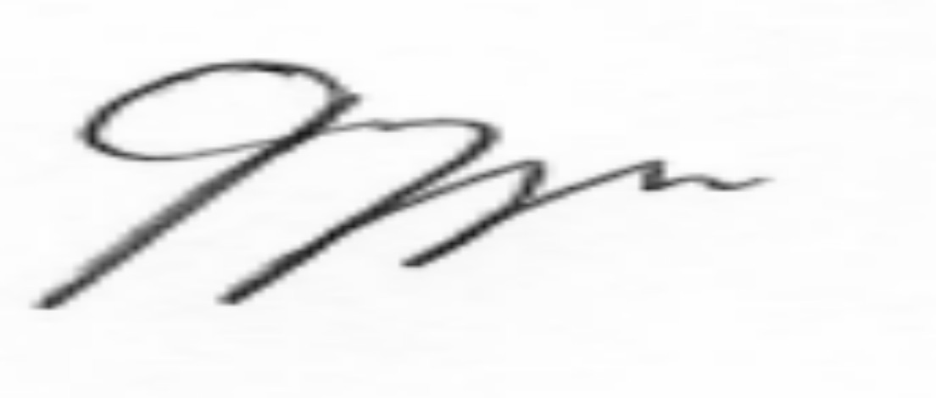
- The plaintiff’s summons claim be and is hereby dismissed with costs.

MANZUNZU J:………………………………………………….

Mlotshwa Solicitors, plaintiff’s legal practitioners
Zvobgo Attorneys, first and second defendants’ legal practitioners

