

PREVAIL INTERNATIONAL (PVT) LTD
versus

GURUVE RURAL DISTRICT COUNCIL
and

THE SHERIFF

HIGH COURT OF ZIMBABWE COMMERCIAL DIVISION MANZUNZU J
HARARE, 6 February & 17 June 2025 Court Application
D Sigauke, for the applicant
A Demo, for the 1st respondent

MANZUNZU J

INTRODUCTION
This is a court application to declare invalid and set aside a writ of execution against the
applicant’s movable property.

The relief sought by the applicant is couched in the following terms;

“IT IS ORDERED THAT
The writ of execution issued by this Court on 8 August 2024 under Case No. HCHC 569/23 is declared to be invalid and set aside.
- Any acts done pursuant to the writ of execution issued under Case No HCHC569/23 are hereby set aside and of no force or effect.
- First Respondent shall pay the costs of this application on the legal practitioner and client scale.”

The application is opposed by the first respondent.

BACKGROUND
- A default judgment in favour of the first respondent as against the applicant in case number HCHC569/23 was granted on 23 November 2023.
- The court order reads as follows:
“1. The defendant shall deliver a Water Drill Reg SR1000 to the plaintiff within 10 days of the date of this order; failing such delivery, the defendant shall pay damages to the plaintiff in the sum of US$392 000.00 together with interest thereon at the prescribed rate calculated from the date of judgement to date of payment in full. 2. The Defendant shall pay costs of suit.”
- The applicant applied for rescission of default judgment in HCHC 766/23 which was later deemed abandoned and dismissed by the Registrar.

- Thereafter, the applicant filed an application to reinstate the application for rescission of default judgment in HCHC578/24 which was dismissed by the court on 18 November 2024.
- A writ of execution against the applicant’s movables was issued in this Court on 8
August 2024 under HCHC 569/23.

- It is this writ which is under attack by the applicant who seeks that it be declared invalid and that it be set aside.
- It is the applicant’s case that the writ is palpably irregular and invalid in that;

  - It was not preceded by a writ of delivery of the water drill rig as required by a court order.
  - It was issued prematurely before enforcement of the main relief for delivery of the water drill rig and before exhaustion of the main remedy.
  - It seeks to enforce the alternative relief for damages before pursing the main relief for delivery.
  - It completely disregards the sequence of recovery spelt out in the court order.

- In a nutshell, the applicant is saying, it is not procedurally permissible, given the nature of the order, to execute on the alternative before one pursues and exhausts on the main relief.
- Both parties raised preliminary points which were either abandoned or dismissed at the hearing and are of no consequence to the resolution of the issue, ‘whether or not the writ is invalid and whether it should be set aside.”
- On the 19th of September 2024 the applicant attempted to deliver a water drill rig which was not accepted by the first respondent. This however, does not assist in the resolution of the issue identified in paragraph 9 above as it is not one of the grounds upon which the applicant seeks the invalidity of the writ. The application before this court is for the setting aside of a writ of execution in HCHC 569/23, not on the ground that there was an attempted delivery, but for the reasons stated in paragraphs 7 and 8 above.

SUBMISSIONS AND ANALYSIS

- The court order under which the writ was drawn is divided into two parts, delivery in 10 days, failure of which, payment of damages. What is its operative interpretation? It simply means, if the applicant fails to deliver in ten days, the 1st respondent is entitled to damages in

the alternative. This brings us to the question whether it is competent for a writ to be drawn for enforcement of delivery only or for damages only or the two must go together.
- A writ of execution derives its validity from the judgment or order it seeks to enforce. Hence, it should not vary terms of the judgment or order. The judgment itself, and not the writ, is the legal basis for the enforcement process. It is the court's determination of the rights and obligations of the parties involved in the case. The writ of execution acts as the court's directive to implement the judgment or order. The writ is a document that authorizes the execution process.
- The applicant made attempts to hide behind the manner of service of the court order upon it. I find no merit in it given the availability of the order on the IECMS platform. In any event the first respondent served the same on the applicant. The applicant has knowledge of the order and has not complied with it within 10 days of its knowledge.
- Rule 69 (1) of the High Court Rules was the focal point of the applicant’s argument and the case of Hwange Coal Gasification Company (Private) Limited v Gutai Lisa-Marie Mutuke HB 30/24.
- I did not find any place for the Hwange Coal Gasification Company case in this case. The applicant seems to confuse the issue of service and execution of a court order. The comparison intended about court orders does not match.
- Rule 69 (1) of the High Court Rules, 2021 states that:
“The process for the execution of any judgment for the payment of money, for the delivery of money, for the delivery up of goods or premises, or for ejectment, shall be by writ of execution signed by the registrar and addressed to the sheriff, in accordance with one or other of Forms Nos. 32 to 39.”

- The applicant read rule 69 (1) in conjunction with form 38, a hybrid writ which deals with delivery of movables failing which attachment of property to recover the amount in damages. It was argued that the rule carries with it the peremptory effect for which the respondent has no choice in the drawing of the writ. Furthermore, applicant argues that it was inappropriate for the first respondent to sue out a writ for the alternative leaving out the main relief.
- The first respondent’s argument was that the order of the court is unambiguous and that rule 69 was merely stating that the execution of a judgment cannot be done without a writ. This interpretation, in my view, accords with rule 69. The rule cannot be used to support the

argument that it compels the 1st respondent to use form 38. The use of form 38 is dependent upon the nature of the order of the court.
- In Bolt Speed Contractors (Pvt) Ltd v Wang Hong Fang & Anor HH747/22 the learned judge held that in terms of rule 69 a judgment is enforceable through a writ of execution even though they take different forms depending on the manner in which it has to be implemented. A writ of execution remains, a writ of execution that was issued pursuant to a judgment or order of court.
- The writ of execution must enforce that which the court has ordered.
- The general rule is that a party who has obtained an order against another is entitled to execute upon it, see Mupini v Makoni 1993 (1) ZLR 80(S) at 83 B-D
- In Shava v Bergus Investments (Pvt) Ltd and Another HH226/11 it was established that it is trite that a writ of execution may be set aside on application if the judgment upon which it was premised was not definite and certain. In casu, that is not the case.
- In the exercise of a wide discretion the court may set aside or suspend a writ of execution where real and substantial justice so demands or where the writ does not strictly follow the form of the court order.
- The applicant referred to Herbstein & Van Winsen, The Civil Practice of the High Courts and Supreme Court of Appeal of South Africa, 5thEdition, page1028 which expressed the view that the writ of execution must follow strictly the form of the court’s order that warrants its issue, otherwise it will be liable to be set aside, if for example the judgment is for the delivery of a certain thing and in the alternative for the payment of money, then the writ should direct the sheriff to obtain delivery of the thing decreed and, only if he/she is unable to do so, to execute on the judgment debtors property to enforce the alternative order for payment of money. The judgment creditor does not enjoy an option to execute, in respect of either alternative, but must abide by the form of the court's order.
- In Finishing Touch 163(Pty) Ltd v BHP Billiton Energy Coal South Africa Ltd [2012] ZASCA 49; 2013(2) SA 204 (SCA) at para 13, cited with approval in Eke v Parsons [2015] ZACC 30; 2016(3) SA 37 (CC); 2015(11)BCLR 1319(CC) at para 29, the Court said: “The
starting point is to determine the manifest purpose of the order. In interpreting a judgment or Order, the Court’s intention is to be ascertained primarily from the language of the judgment or Order in accordance with the usual well – known rules relating to the interpretation of documents.”

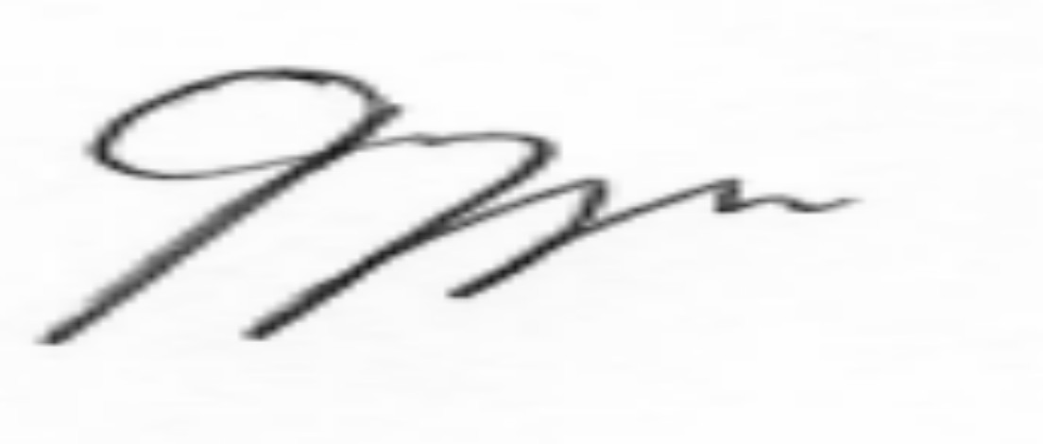
- In Baron v George 1994 (2) ZLR 141 (S) at p 145 MCNALLY JA stated: “An order of
court must be presumed, where it is not ambiguous, to mean what it says.
What then does the order of this court say? It says; “1. The defendant shall deliver a Water Drill Reg SR1000 to the plaintiff within 10 days of the date of this order; failing such delivery, the defendant shall pay damages to the plaintiff in the sum of US$392
000.00 together with interest thereon at the prescribed rate calculated from the date of
judgement to date of payment in full. 2. The Defendant shall pay costs of suit.”

- The question then is, “did the applicant deliver in 10 days?” The answer is no. Failure to deliver triggers the right upon the first respondent to pursue damages as it did. The situation should have been different if the order was merely saying “deliver or pay a certain amount.” In casu, the order sets a precondition before one pursues damages. If delivery was done, then damages falls away. It was within the first respondent’s right to issue a writ for the alternative and that accords with the court order.
- The payment of damages became automatic upon the applicant’s failure to deliver the water rig within the stipulated 10 days in the court order. A writ of execution once issued shall remain in force until such time as the judgment has been satisfied, rule 69(3) High Court Rules 2021.
- While the first respondent has asked for costs on a higher scale such has not been motivated in the heads.

DISPOSITION

IT IS ORDERED THAT
The application be and is hereby dismissed with costs.

MANZUNZU J…………………………………………………. Musengi and Sigauke, applicant’s legal practitioners Chihambakwe and Partners, first respondent’s legal practitioners

